Source codes

import numpy as np

import cv2

img = cv2.imread('/Users/louis/Downloads/Bird 3 blurred.tif')

cv2.imshow("Original", img)

x, y, z = img.shape

r = img[:, :, 0]

b = img[:, :, 1]

g = img[:, :, 2]

H = 0

S = 0

I = 0

*# print(img.shape)*

*# print(r.shape)*

*# calculating I image*

I = r / 3 + b / 3 + g / 3

I = I.astype(np.uint8)

*# print(I)*

*# calculating S image*

S = np.minimum(r, b)

S = np.minimum(S, g)

S = S / I

S = 1 - S

S = S * 255

S = S.astype(np.uint8)

*# print(S)*

*# calculate H image*

r = r.astype(int)

b = b.astype(int)

g = g.astype(int)

*# for i in range(len(H)):*

*# for j in range(len(H[0])):*

*# max_=max(max(r[i,j],b[i,j]),g[i,j])*

*# min_=min(min(r[i,j],b[i,j]),g[i,j])*

*# if min_==max_:*

*# H[i,j]=0*

*# if max_==r[i,j]:*

*# H[i,j] = (g[i,j] - b[i,j]) / (max_ - min_)*

*# elif max_==b[i,j]:*

*# H[i,j] = 2.0 + (b[i,j] - r[i,j]) / (max_ - min_)*

*# else:*

*# hue = 4.0 + (r[i,j] - g[i,j]) / (max_ - min_)*

*# H[i,j] = H[i,j] * 60*

*# if (H[i,j] < 0):*

*# H[i,j] = H[i,j] + 360*

*# #*

numerator = r - g / 2 - b / 2

denominator = np.sqrt(r * r + b * b + g * g - r * b - b * g - r * g)

H = np.arccos(numerator / denominator)

H = 180 * H / np.pi

for i in range(len(H)):

for j in range(len(H[0])):

if b[i, j] > g[i, j]:

H[i, j] = 360 - H[i, j]

print(numerator)

print(denominator)

H = H.astype(np.uint8)

print(H)

r = r.astype(np.uint8)

b = b.astype(np.uint8)

g = g.astype(np.uint8)

RBG_back=np.stack((r,b,g))

print(RBG_back.shape)

RBG_back=np.rot90(RBG_back)

RBG_back=np.rot90(RBG_back,k=3,axes = (2, 1))

RBG_back=np.rot90(RBG_back, k=2)

print(RBG_back.shape)

print(img.shape)

HSI_back=np.stack((H,S,I))

print(HSI_back.shape)

HSI_back=np.rot90(HSI_back)

HSI_back=np.rot90(HSI_back,k=3,axes = (2, 1))

HSI_back=np.rot90(HSI_back, k=2)

print(HSI_back.shape)

RBG_HSI=RBG_back-HSI_back

*# RBG_HSI=RBG_HSI/np.linalg.norm(RBG_HSI)*

RBG_HSI = cv2.normalize(RBG_HSI, None, alpha=0, beta=1, norm_type=cv2.NORM_MINMAX, dtype=cv2.CV_32F)

*# RBG_HSI[:,:,0]=RBG_HSI[:,:,0]/np.linalg.norm(RBG_HSI[:,:,0])*

*# RBG_HSI[:,:,1]=RBG_HSI[:,:,1]/np.linalg.norm(RBG_HSI[:,:,1])*

*# RBG_HSI[:,:,2]=RBG_HSI[:,:,2]/np.linalg.norm(RBG_HSI[:,:,2])*

HSI_RBG=HSI_back-RBG_back

*# HSI_RBG=HSI_RBG/np.linalg.norm(RBG_HSI)*

HSI_RBG = cv2.normalize(HSI_RBG, None, alpha=0, beta=1, norm_type=cv2.NORM_MINMAX, dtype=cv2.CV_32F)

*# HSI_RBG[:,:,0]=HSI_RBG[:,:,0]/np.linalg.norm(RBG_HSI[:,:,0])*

*# HSI_RBG[:,:,1]=HSI_RBG[:,:,1]/np.linalg.norm(RBG_HSI[:,:,1])*

*# HSI_RBG[:,:,2]=HSI_RBG[:,:,2]/np.linalg.norm(RBG_HSI[:,:,2])*

print(HSI_RBG)

cv2.imshow("I image",I)

cv2.imshow("S image",S)

cv2.imshow("H image", H)

cv2.imshow("Output RGB image", RBG_back)

cv2.imshow("Output HSI image", HSI_back)

cv2.imshow("Output RGB-HSI image", RBG_HSI)

cv2.imshow("Output HSI-RBG image", HSI_RBG)

cv2.imshow("R image",r)

cv2.imshow("B image",b)

cv2.imshow("G image",g)

cv2.waitKey(0)

cv2.destroyAllWindows()

Figures of R, G, B, H, S and I component images

R image

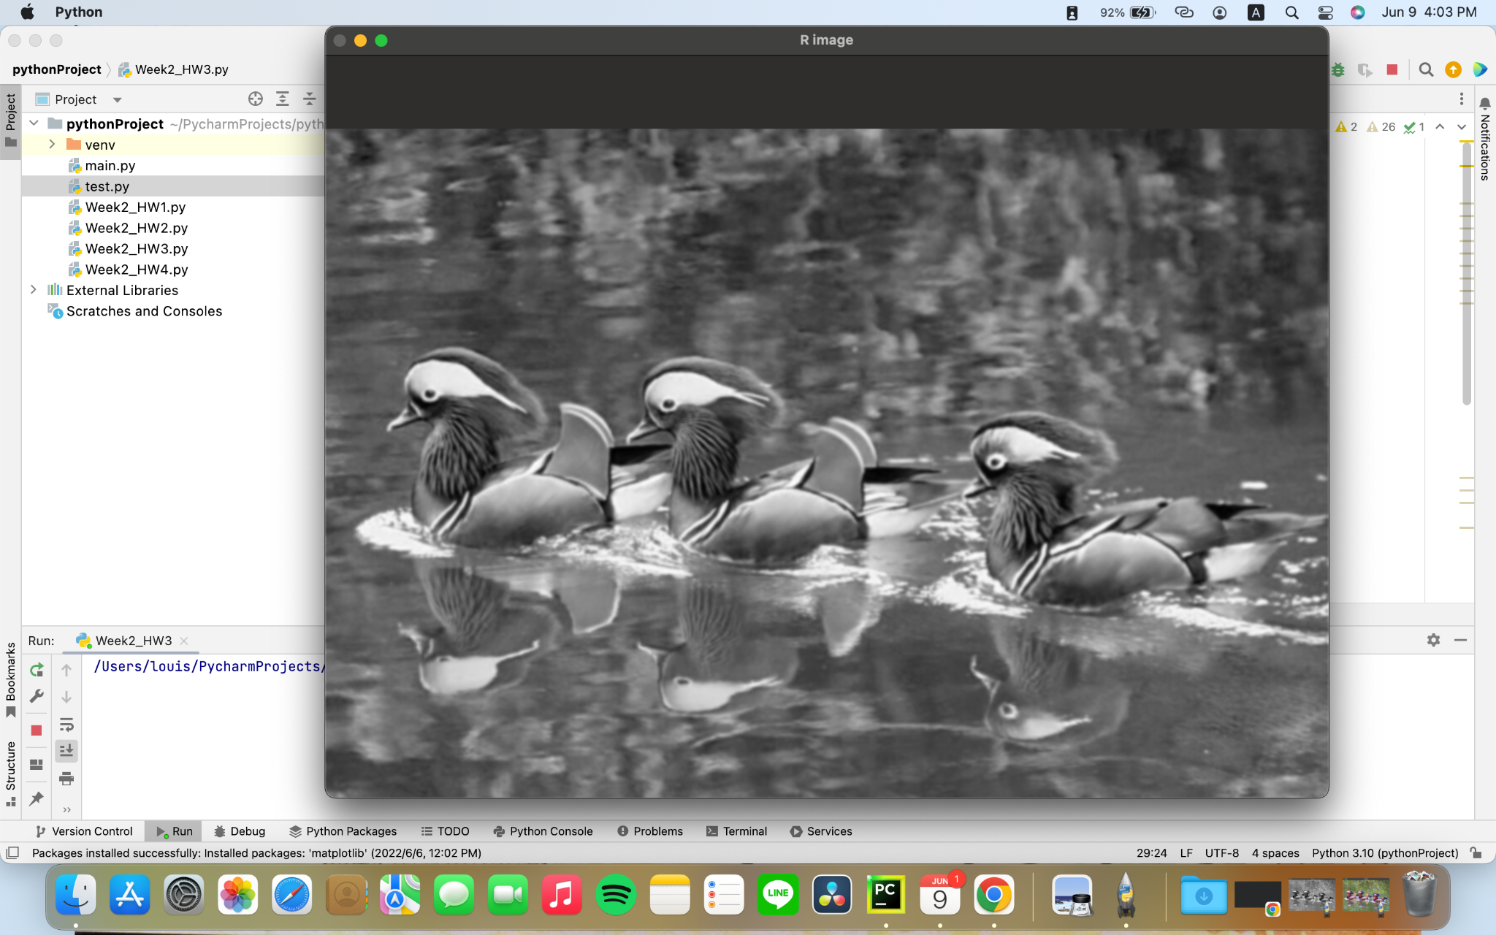

G image

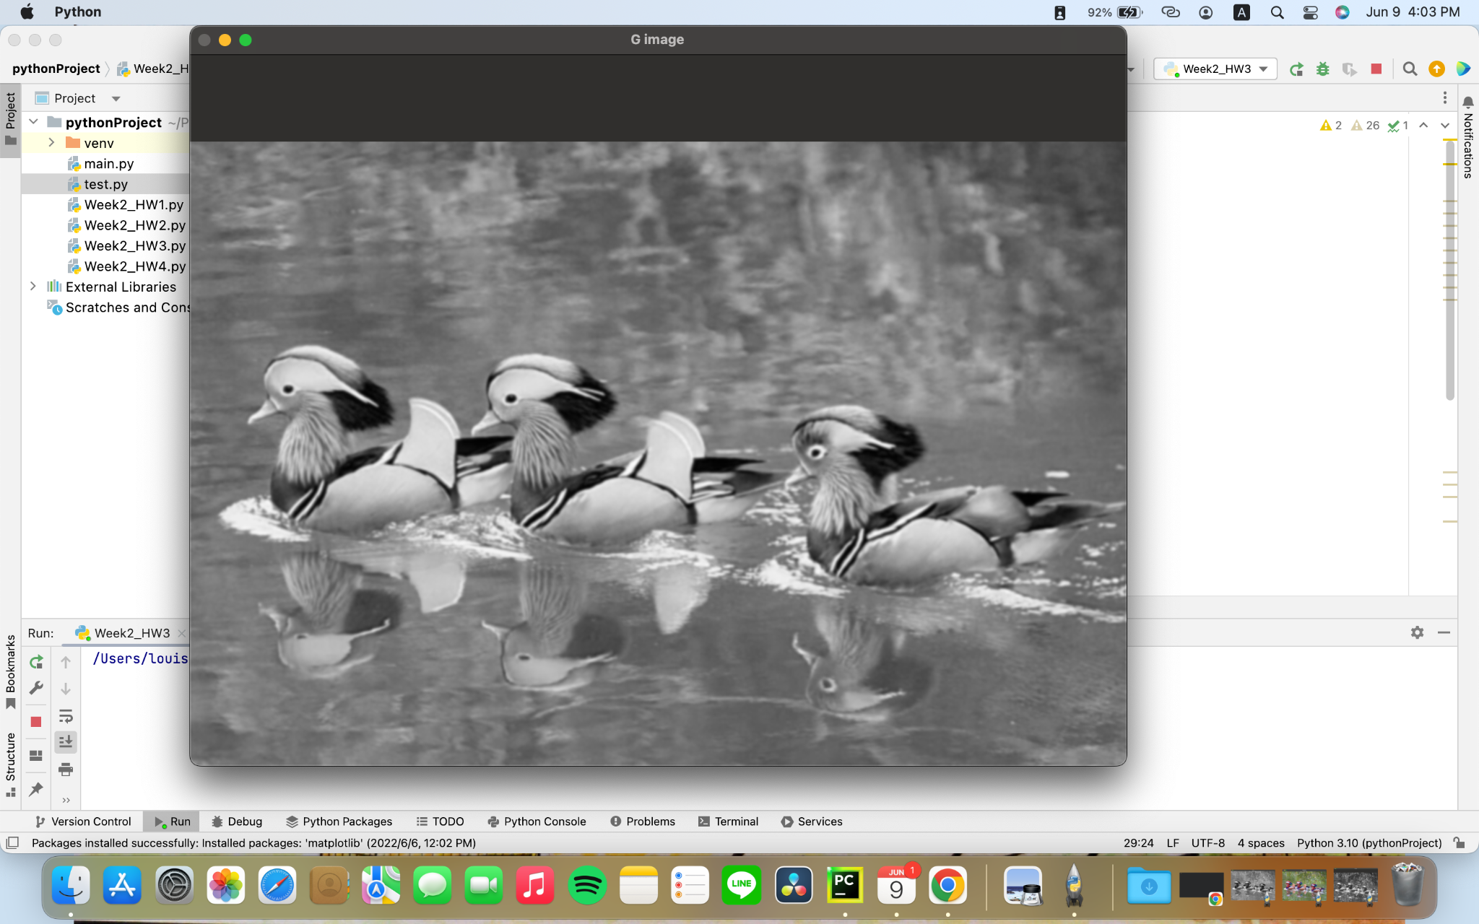

B Image

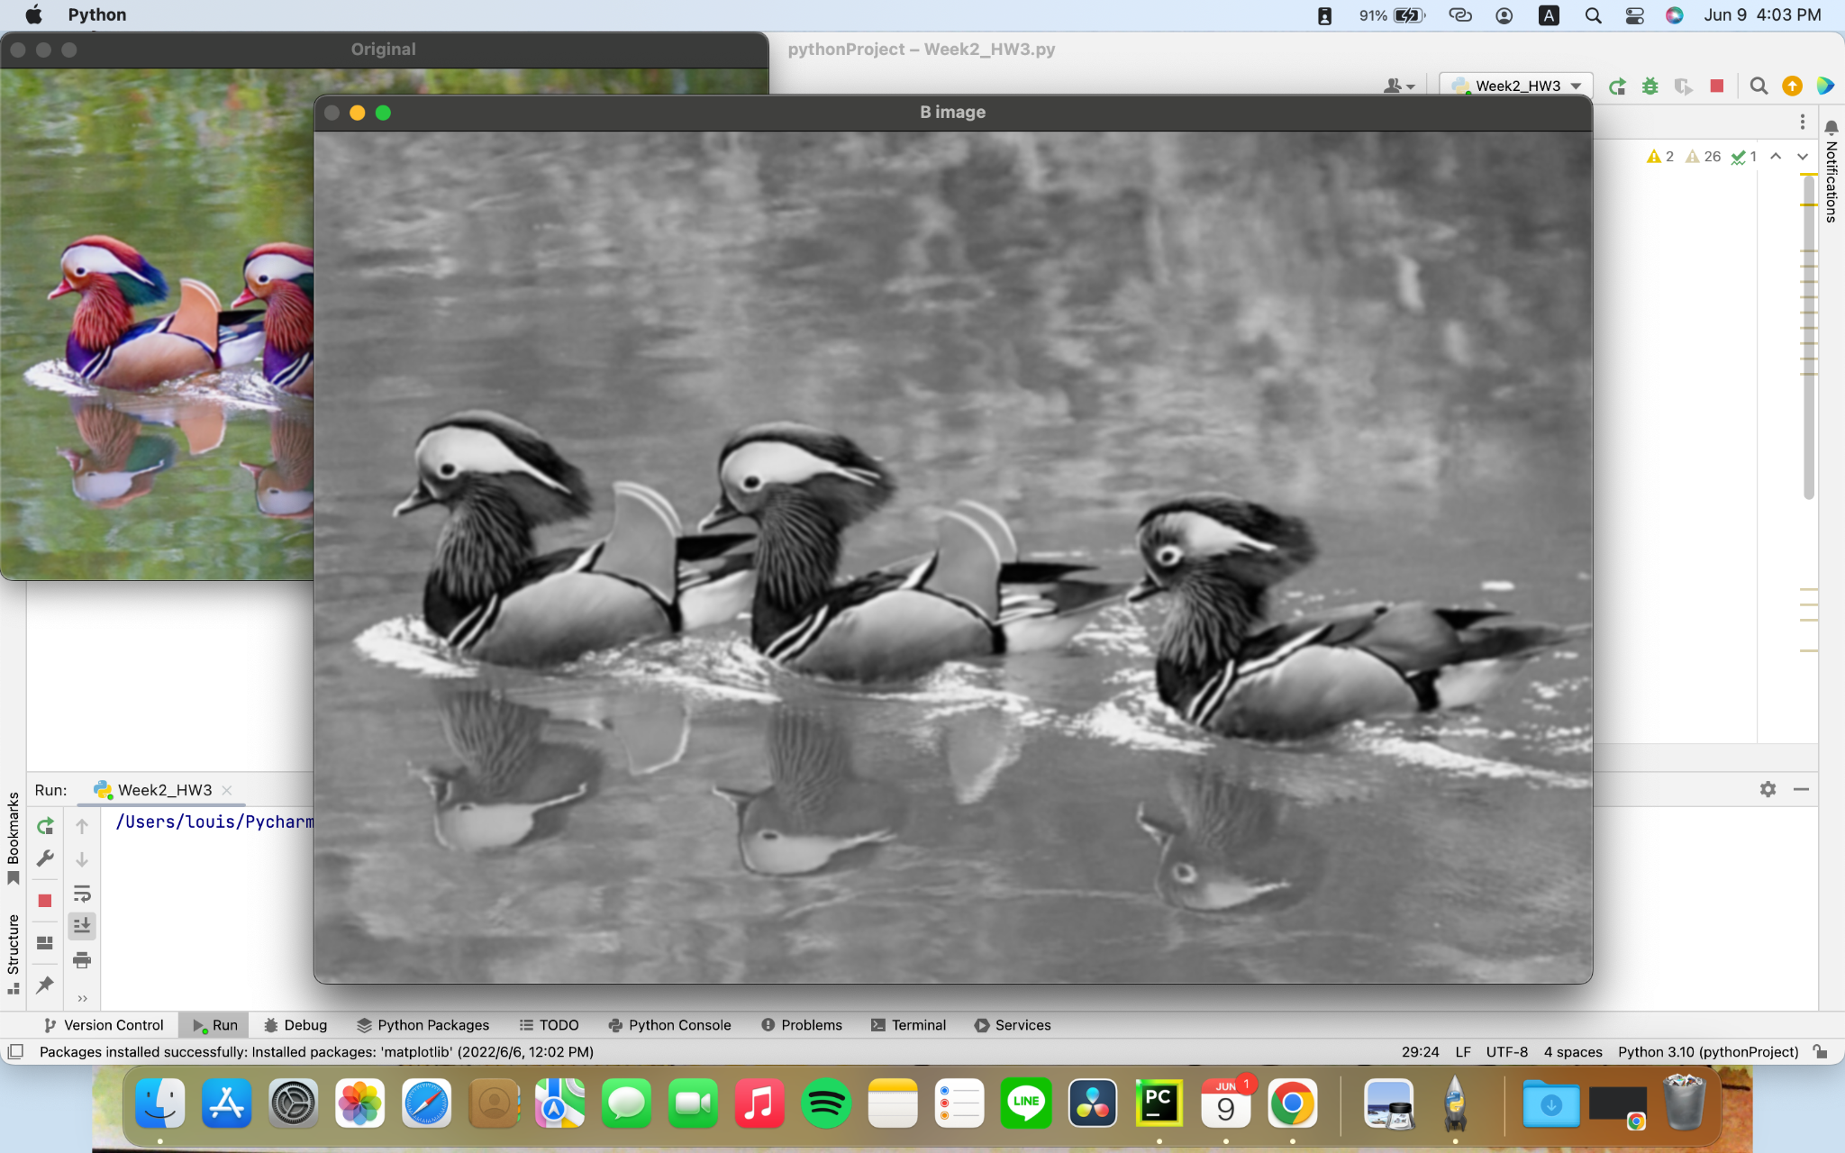

H Image

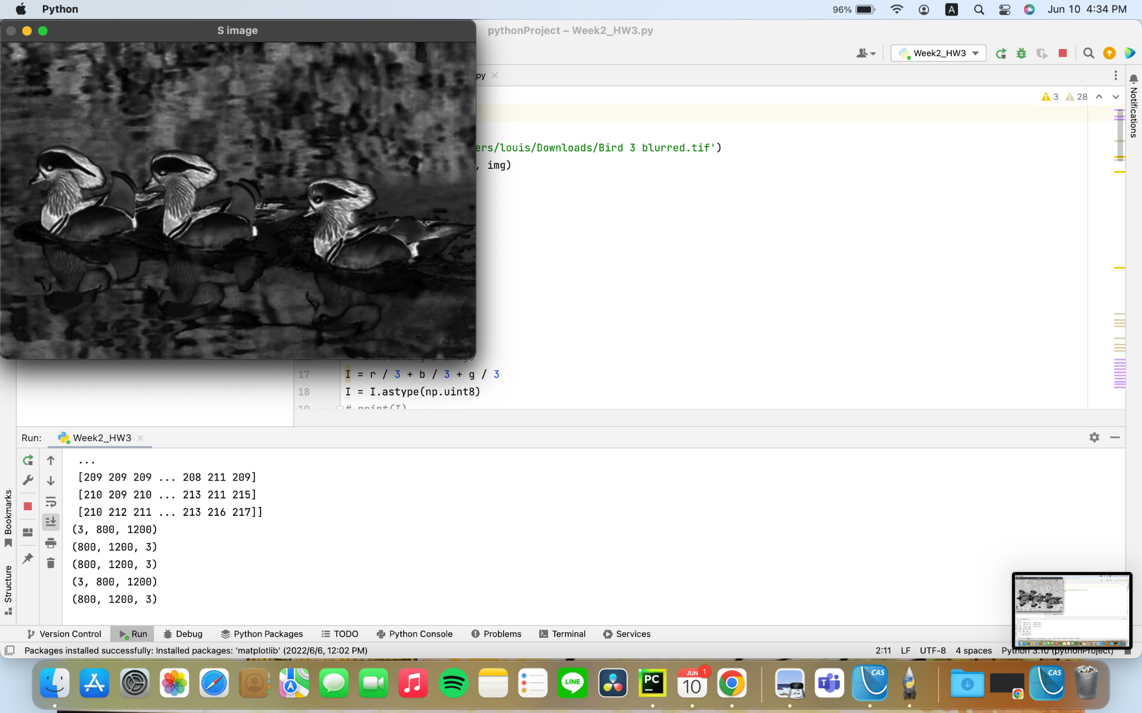

S Image

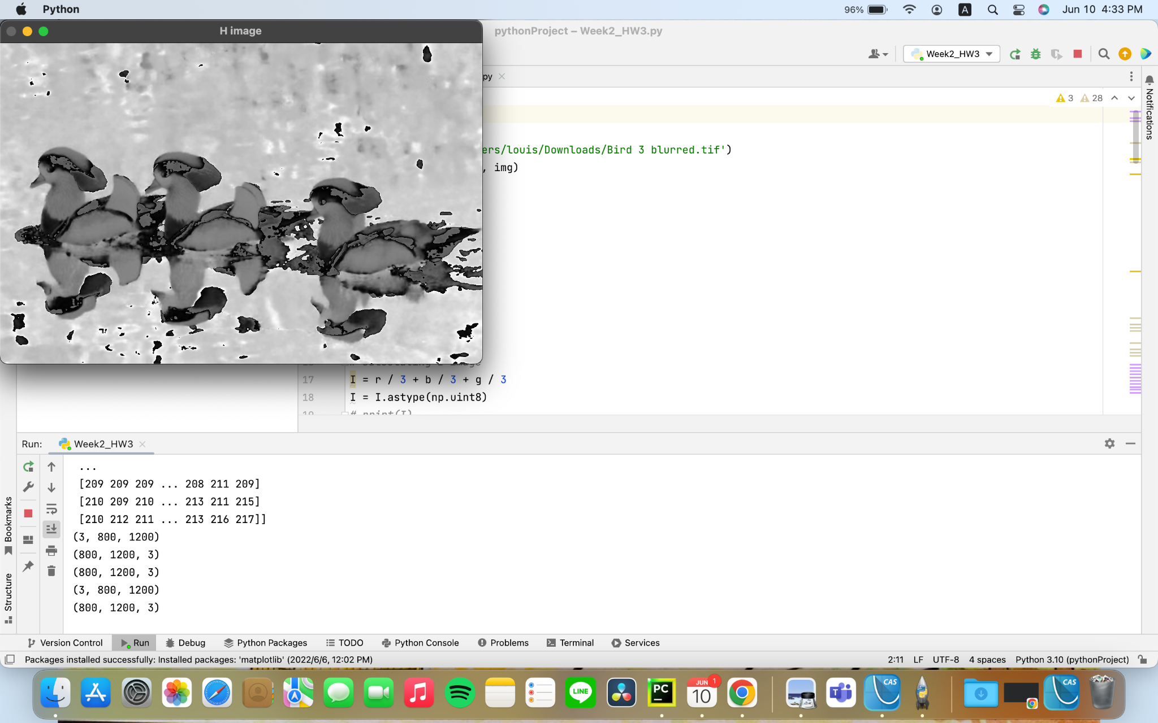

I Image

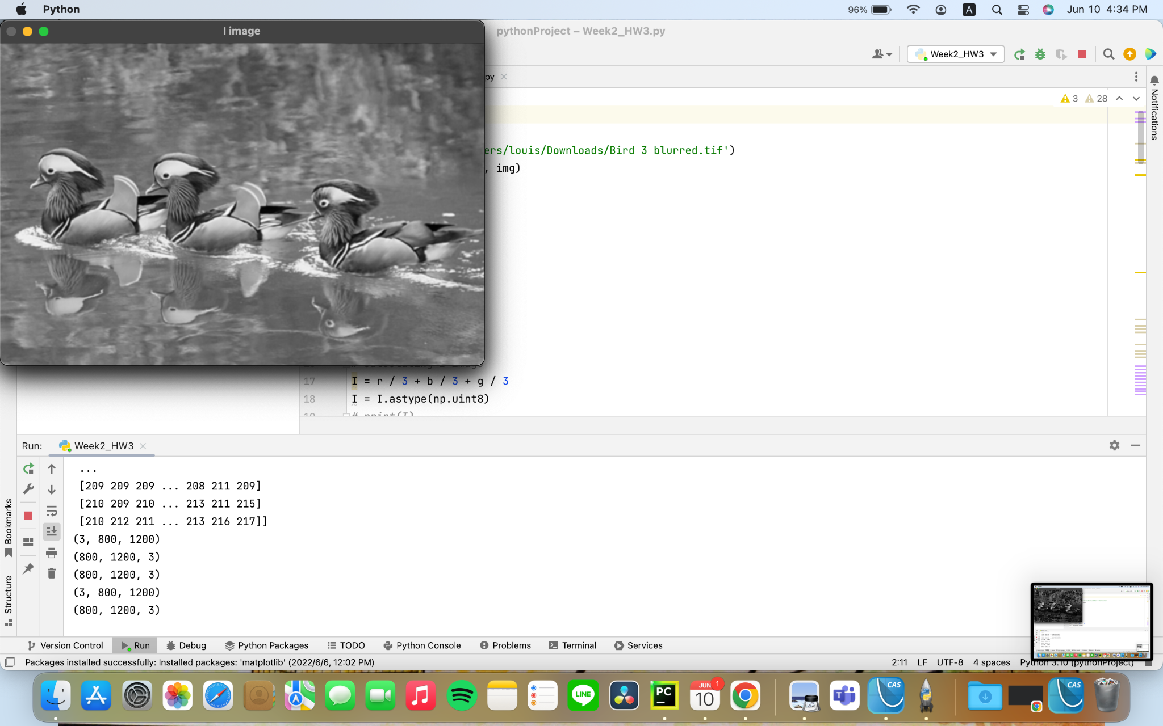

Figures of RGB-based and HSI-based sharpened images and their

difference image

RGB-HSI Image

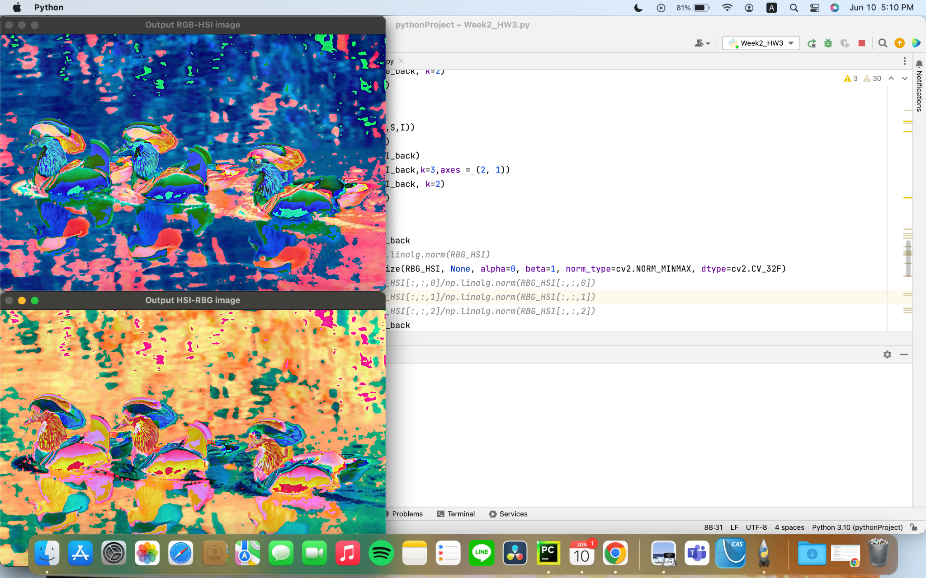

HSI-RGB Image

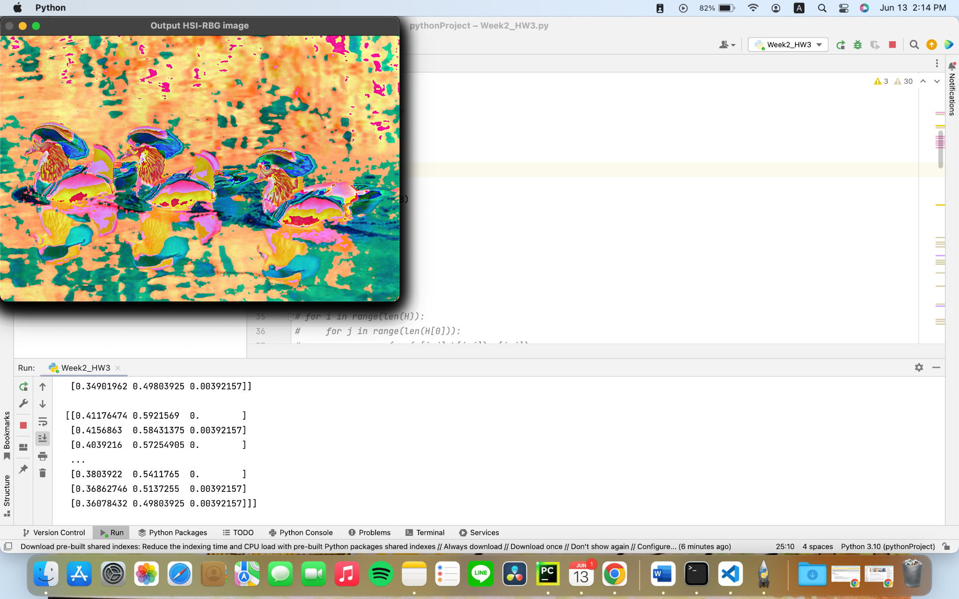

Output HSI Image

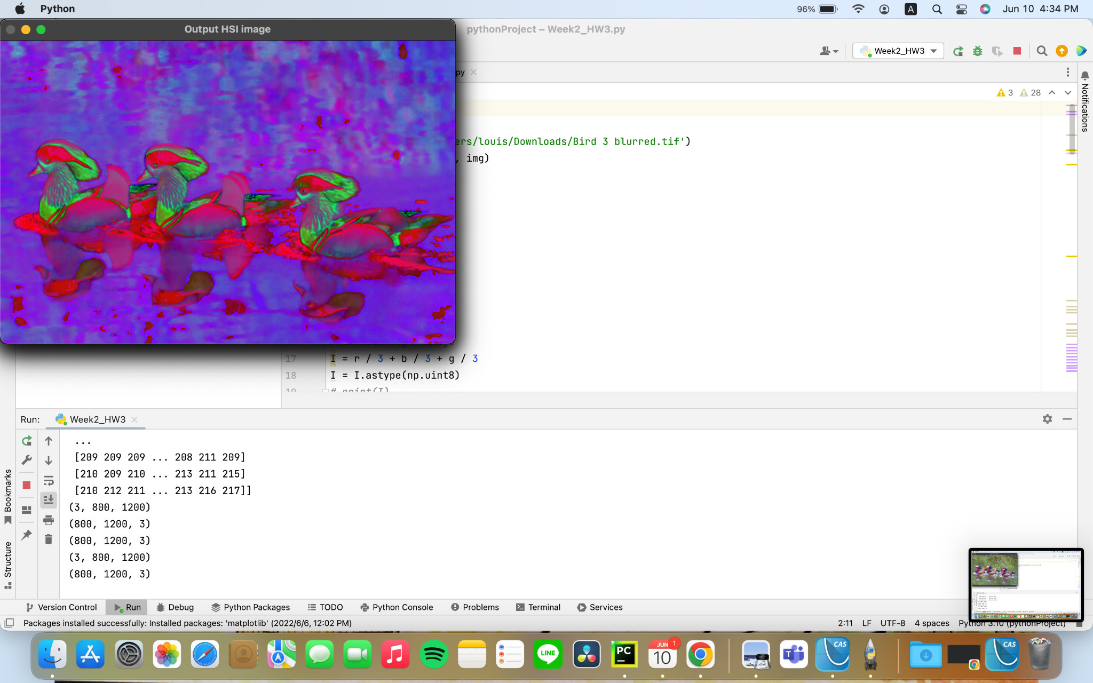

Output RGB Image

